Digital Audio Workstation
PennWest California

Design Document

CMSC 4900 – Senior Project I

Group Members:
Brandon Smith
Clayton Sanner
Alice Bruce

Instructor Comments/Evaluation

Table of Contents
Abstract---------------------------------------------------------------------------------------------------------5
Description of the Document--------------------------------------------------------------------------------5
Purpose and Use--------------------------------------------------------------------------------------5
Ties to the Specification Document----------------------------------------------------------------6
Intended Audience-----------------------------------------------------------------------------------6
Project Block Diagram with Description-------------------------------------------------------------------6
Design Details-------------------------------------------------------------------------------------------------7
System Modules and Responsibilities-------------------------------------------------------------7
Architectural Diagram----------------------------------------------------------------------7
Module Cohesion----------------------------------------------------------------------------8
Module Coupling----------------------------------------------------------------------------8
Design Analysis--------------------------------------------------------------------------------------9
Data Flow------------------------------------------------------------------------------------9
Design Organization--------------------------------------------------------------------------------9
Detailed tabular description of classes and objects--------------------------------10-14
Functional Description----------------------------------------------------------------14-45
Files Accessed------------------------------------------------------------------45 Real-Time Requirements-----------------------------------------------------45
Messages-----------------------------------------------------------------------46
Narrative/PDL-----------------------------------------------------------------46
Decision: Programming language/reuse/Portability------------------------------49
Implementation---------------------------------------------------------------------------------49
Design Testing---------------------------------------------------------------------------------50
Citations-------------------------------------------------------------------------------------------------51
Appendix: Team Details------------------------------------------------------------------------------52
Appendix: Writing Center Report------------------------------------------------------------------52
Appendix: Workflow Authentication--------------------------------------------------------------53

Abstract
The Digital Audio Workstation is intended to help musical artists and composers by providing software to create music using different synthetic instruments and individual tracks for each instrument that can be stacked to play at the same time which are saved as MIDI files that can also be imported into the program for editing. While many existing DAWs provide these features, they tend to be very complex and complicated to use and are expensive for individuals. Existing DAWs are usually very complex and complicated software which takes a lot of time simply to learn and understand all the functions they provide while also having prices in the range of $100-$200(Create your best music, Creative tools for music makers). The team aims to provide these common features while providing a much more affordable, user-friendly, and easily available option. The creation of this software will provide a lower barrier to entry for amateur and professional music creation. The document will show the development and project plan for the future of the project.

Description of the Document
Purpose and Use
The purpose of this document is to give the project team a strong guideline to follow when developing the project. In addition, it will detail the programming languages and tools that will be used to develop the project. The project team will use the design document throughout development to keep track of the plans for the project and keep the scope of the project from growing further than what was promised which could potentially drop the quality of the project.
Ties to the specification document
The design document ties to the specification document by extending the promises and details given by the specification document under a programming and development lens. It will show details of the planned programming of the project as well as the architecture of the program. Many of the promised features of the specification document should be able to be understood by the class descriptions of this document.
Intended Audience
The intended audience for this document would be those with a background in programming and can clearly understand programming language and pseudocode concepts. It can be used to understand the project on a deeper level for other software developers and designers. The open-source nature of this team’s project will make this document more important as it can help other developers that wish to change the project understand get a better grasp of the techniques used to develop the program. This document is not intended for potential clients who simply wish to use the program as is as the language in this document will not be formatted in a way for the average client to understand. If a client wishes to see and understand this document it is advisable to have some form of third-party more familiar with coding languages to summarize and help them understand this document.
Project Block Diagram with Description
The software is divided into three main sections, the timeline, the project, and the editor. The file manager of the PC is also used significantly, as the nature of the software requires opening, editing, and saving multiple files per project. Individual files can be opened and placed onto the timeline, which is also assigned to and stored within the project. MIDI tracks on the timeline can be opened in the editor for manipulation at the user’s discretion. The project may be saved to the PC file manager, as well as opened from the same location to continue work at a later time.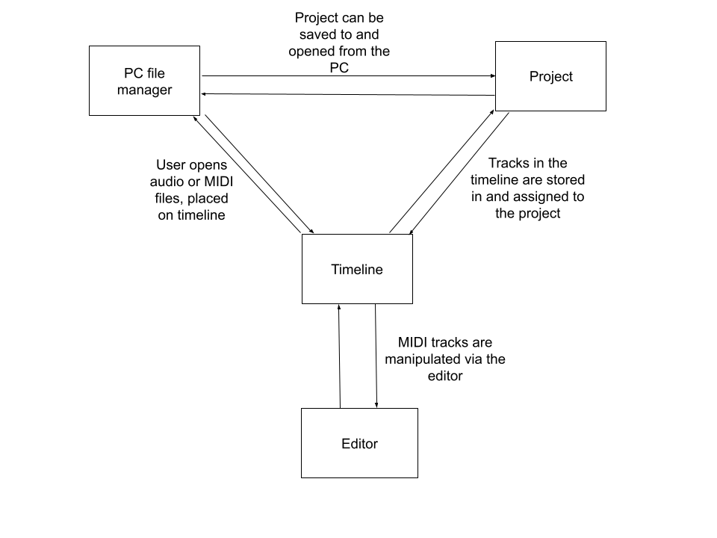

Design Details
System Modules and responsibilities
Architectural Diagram
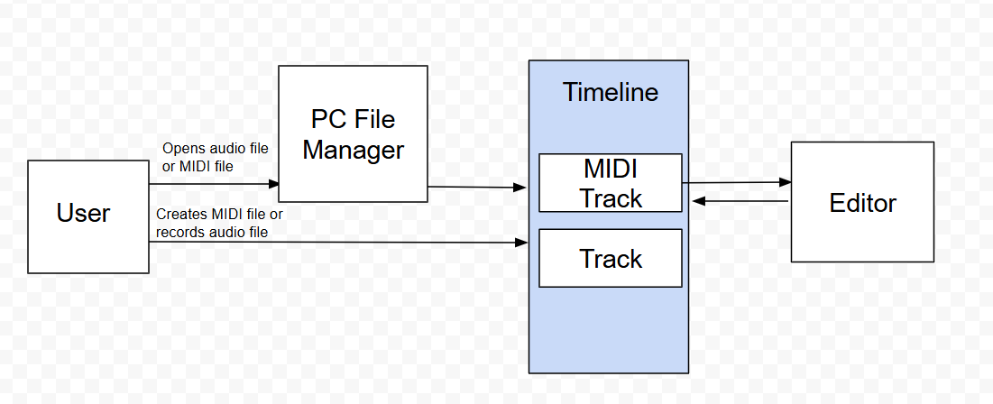
The architectural diagram shows the user adding a new file (MIDI file or audio file) to the timeline, whether that be creating a new file or opening an existing one. In either case, the file is placed onto the timeline using the appropriate track type. MIDI files, which will always be in a MIDI track, can then be opened in the editor, where data is passed back and forth as changes are made.
Module Cohesion
This software has high cohesion, as classes only rely on each other when they need to. The file manager is not needed when creating new MIDI or audio files, so that class is not used. MIDI tracks and audio tracks have separate classes as they have separate, unique functions, which avoids coupling.
Module coupling
While this software has coupling, it is only utilized where necessary. Both the MIDI track class and the track class both rely on the timeline class, as both exist in the timeline in the software’s GUI. The editor class relies on the MIDI track class as it works directly with it; data is passed between the two classes frequently, making this coupling necessary.
Design Analysis
Data Flow
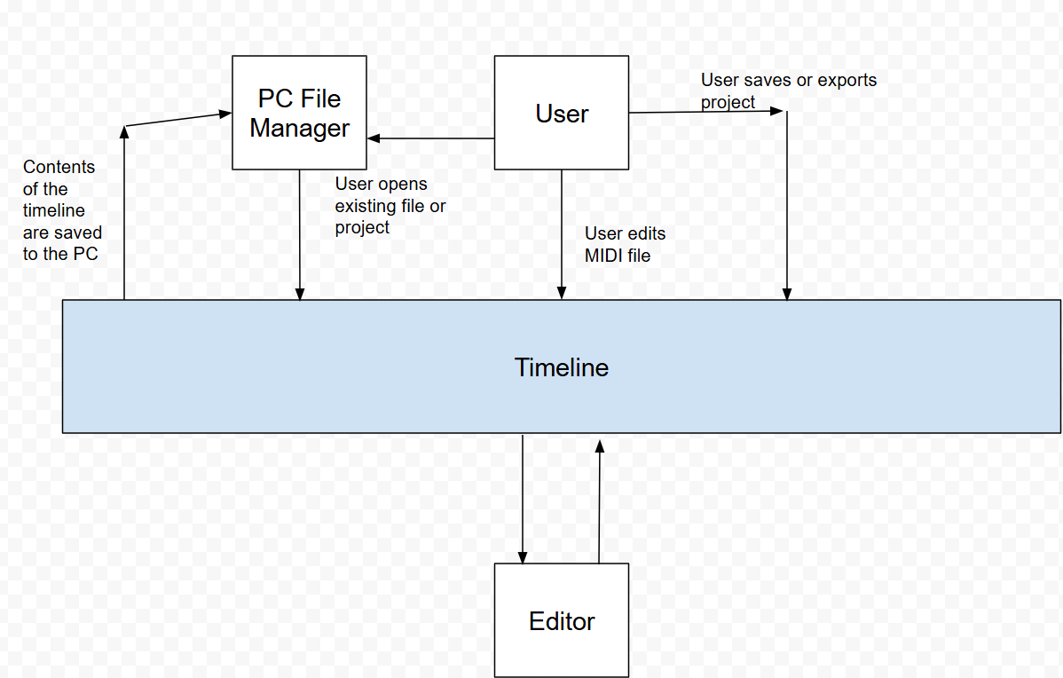
This diagram shows the data flow between the user, the timeline, the editor, and the PC file manager. The user opens a file or project from the PC file manager, which is stored into tracks on the timeline. The user can open a MIDI file in the editor, where data is passed back and forth between the editor and the track on the timeline until the user closes the editor. The user can save or export the project, which saves the contents of the timeline to the PC file manager. .(“programming MIDI”, 2020)

Design Organization
Detailed tabular description of classes and objects
Class Name: Timeline
Class Description: Will control the tempo and the time signature of the current project as well as hold the number of tracks that current exist on the timeline
Class data members: double tempo, int TimeSigNum, int TimeSigDenom, double length, bool IsPlaying, bool IsLooping, double LoopStart, double LoopEnd
Class member functions: getTempo(), setTempo(double tempo), getTimeSigNum (), setTimeSigNum (int TimeSigNum), getTimeSigDenom (), setTimeSigDenom(int TimeSigDenom), getLength(), setLength(int length), getIsPlaying(), setIsPlaying(bool IsPlaying), getIsLooping(), setIsLooping(bool IsLooping), getLoopStart(), setLoopStart(double LoopStart), getLoopEnd(), setLoopEnd(double LoopEnd)

Class Name: Editor
Class Description: Will manage and create editor elements in the program that will be used to edit and change the audio and MIDI files
Class data members: double ViewStart, double ViewEnd, double ZoomX, double ZoomY, bool IsDragging, bool IsDrawing, bool IsSelecting
Class member functions: getViewStart(), setViewStart(double ViewStart), getViewEnd(), setViewEnd(double ViewEnd), getZoomX(), setZoomx(double ZoomX), getZoomY(), setZoomY(double ZoomY), getIsDragging(), setIsDragging(bool IsDragging), getIsDrawing(), setIsDrawing(bool IsDrawing), getIsSelecting(), setIsSelecting(bool IsSelecting)

Class Name: Import
Class Description: Will allow user to import an audio or MIDI file into the project to work on
Class data members: string FileName, string FileExtension, int TrackIndex, double StartTime, int TrackCount
Class member functions: getFilename(), setFileName(String FileName), getFileExtension(), setFileExtension(string FileExtension), getTrackIndex(), setTrackIndex(int TrackIndex), getStartTime(), setStartTime(double StartTime), getTrackCount(), setTrackCount(int TackCount)

Class Name: Export
Class Description: Will allow user to export an audio or MIDI file to their file system
Class data members: string OutputFilePath, string OutputFileDirect, string FileName, string FileExtension, int SampleRate, double StartTime
Class member functions: getOutputFilePath(), setOutputFilePath(string OutputFilePath), getOutputFileDirect(), setOutputFileDirect(string OutputFileDirect), getFileName(), setFileName(string FileName), getFileExtension(), setFileExtension(string FileExtension), getSampleRate(), setSampleRate(int SampleRate), getStartTime(), setStartTime(double StartTime)

Class Name: MIDIEvent
Class Description: Will allow the user to manage and perform changes to midi events on the tracks
Class data members: double Time, int Channel, string EventType, int NoteNum, int Duration
Class member functions: getTime(), setTime(double Time), getChannel(), setChannel(int Channel), getEventType(), setEventType(string EventType), getNotNum(), setNoteNum(int NoteNum), getDuration(), setDuration(int Duration)

Class Name: MIDITrack
Class Description: Will create the track for the MIDI file and events
Class data members: string TrackName, int Channel, String Instrument, bool Muted, bool Solo
Class member functions: getTrackName(), setTrackName(string TrackName), getChannel(), setChannel(int Channel), getInstrument(), setInstrument(string Instrument), getMuted(), setMuted(bool Muted), getSolo(), setSolo(bool Solo)

Class Name: AudioTrack
Class Description: Will create the track for the audio file and events
Class data members: string TrackName, float Volume, float Pan, bool Muted, bool Solo
Class member functions: getTrackName(), setTrackName(string TrackName), getVolume(), setVolume(float Volume), getPan(), setPan(float Pan), getMuted(), setMuted(bool Muted), getSolo(), setSolo(bool Solo)

Class Name: PeripheralRecog
Class Description: Will recognize and incorporate peripheral connections in to the project
Class data members: vector<Peripherla> ConnectedDevice, vector<string> SupportedDevice, bool IsScanning, string ErrorMessage
Class member functions: getConnectedDevices(), getErrorMessage(), getSupportedDevice, setSupporteddDevice(vector<string> SupportedDevice) void ScanForDevices,

Class Name: FileBrowser
Class Description: Will allow the user to browse their local files to import or export files
Class data members: string CurDirectory, string SelectedFile, string Search, string LastOpened, bool ShowHidden
Class member functions: getCurDirectory(), setCurDirectory(string CurDirectory), getSelectedFile(), setSelectedFile(string SelectedFile), getSearch(), setSearch(string Search), getLastOpened(), setLastOpened(string LastOpened), getShowHidden(), setShowHidden(bool ShowHidden)

Class Name: Project
Class Description: Will be used to manage the different project running in the program
Class data members: string ProjectName, string FilePath, double Tempo, string TimeSig, double ProjectLength
Class member functions: getProjectName(), setProjectName(string ProjectName), getFilePath(), setFilePath(string FilePath), getTempo(), setTempo(double Tempo), getTimeSig(), setTimeSig(string TimeSig), getProjectLength(), setProjectLength(double ProjectLength)

Functional Description
TimeLine Class
getTempo()
Input: None
Output: Retrieves the tempo of the time line
Return Parameters: Returns the time line tempo as a double
Types: double data type is used
setTempo(double Tempo)
Input: Accepts a double tempo to set the TimeLIne Output: none
Return Parameters: None
Types: Double data type is used
getTimeSigNum()
Input: None
Output: Retrieves the Time signature numerator of the time line
Return Parameters: Returns the Time signature numerator as a int
Types: int data type is used
setTimeSigNum(int TimeSigNum)
Input: Accepts a int time signature numerator to set the time line
Output: None
Return Parameters: None
Types: Int data type is used
getTimeSigDenom()
Input: None
Output: Retrieve the time signature denominator of the time line
Return Parameters: Return the time signature denominator as a int
Types: int data type is used
setTimeSigDenom(int TimeSigDenom)
Input: Accepts an int time signature denominator to set the time line
Output: None
Return Parameters: None
Types: int data type is used
getLength()
Input: None
Output: Retrieves the length of the time line
Return Parameters: Return the length as a double
Types: Double data type is used
setLength(double Length)
Input: Accepts a double length to set the time line
Output: None
Return Parameters: None
Types: Double Data type is used
getIsPlaying()
Input: None
Output: Retrieves Boolean value of IsPlaying for the timeline
Return Parameters: Return IsPlaying as a Boolean
Types: Boolean data type is used
setIsPlaying(bool IsPlaying)
Input: Accepts a Boolean to set IsPlaying
Output: None
Return Parameters: None
Types: Boolean data type is used
getIsLooping()
Input: None
Output: Retrieves Boolean value of IsLooping for the time line
Return Parameters: Return IsLooping as a Boolean
Types: Boolean data type is used
setIsLooping(bool IsLooping)
Input: Accepts a Boolean to set IsLooping
Output: None
Return Parameters: None
Types: Boolean data type is used
getLoopStart()
Input: None
Output: Retrieves LoopStart of time line
Return Parameters: Return the LoopStart as double value
Types: Double data type is used
setLoppStart(double LoppStart)
Input: Accepts a double to set LoopStart
Output: None
Return Parameters: None
Types: Double data type is used
getLoopEnd()
Input: None
Output: Retrieves LoopEnd of time line
Return Parameters: Return the LoopEnd as a double value
Types: Double data type is used
setLoopEnd(double LoopEnd)
Input: Accepts a double to set LoopEnd
Output: None
Return Parameters: None
Types: Double data type is used
Editor Class
getViewStart()
Input: None
Output: Retrieves ViewStart for the Editor
Return Parameters: Return the ViewStart as a double value
Types: Double data type is used
setViewStart(double ViewStart)
Input: Accepts a double to set ViewStart
Output: None
Return Parameters: None
Types: Double data type is used
getViewEnd()
Input: None
Output: Retrieves ViewEnd for the Editor
Return Parameters: Returns the ViewEnd as a double value
Types: Double data type is used
setViewEnd(double ViewEnd)
Input: Accepts a double value to set ViewEnd
Output: None
Return Parameters: None
Types: Double data type is used
getZoomX()
Input: None
Output: Retrieves ZoomX for the Editor
Return Parameters: Returns the ZoomX as a double value
Types: Double data type is used
setZoomX(double ZoomX)
Input: Accepts a double value to set ZoomX
Output: None
Return Parameters: None
Types: Double data type is used
getZoomY()
Input: None
Output: Retrieves ZoomY for the Editor
Return Parameters: Returns the ZoomY as a double value
Types: Double data type is used
setZoomY(double ZoomY)
Input: Accepts a double value to set ZoomY
Output: None
Return Parameters: None
Types: Double data type is used
getIsDragging ()
Input: None
Output: Retrieves IsDragging for the Editor
Return Parameters: Returns the IsDragging as a Boolean value Types: Boolean data type is used
setIsDragging (bool IsDragging)
Input: Accepts a Boolean value to set IsDragging
Output: None
Return Parameters: None
Types: Boolean data type is used
getIsDrawing ()
Input: None
Output: Retrieves IsDrawing for the Editor
Return Parameters: Returns the IsDrawing as a Boolean Value
Types: Boolean data type is used
setIsDrawing (bool IsDrawing)
Input: Accepts a Boolean value to set IsDrawing
Output: None
Return Parameters: None
Types: Boolean data type is used
getIsSelecting ()
Input: None
Output: Retrieves IsSelecting for the Editor
Return Parameters: Returns the IsSelecting as a Boolean value
Types: Boolean data type is used
setIsSelecting (bool IsSelecting)
Input: Accepts a Boolean value to set IsSelecting
Output: None
Return Parameters: None
Types: Boolean data type is used
Import Class
getFileName ()
Input: None
Output: Retrieves FileName for the import
Return Parameters: Returns the FileName as a string of characters
Types: String data type is used
setFileName (string FileName)
Input: Accepts a string of characters to set FileName
Output: None
Return Parameters: None
Types: String data type is used
getFileExtension ()
Input: None
Output: Retrieves FileExtension for the import
Return Parameters: Returns the FileExtension as a string of characters
Types: String data type is used
setFileExtension (string FileExtension)
Input: Accepts a string of characters to set FileExtension
Output: None
Return Parameters: None
Types: String data type is used
getTrackIndex ()
Input: None
Output: Retrieves TrackIndex for the import
Return Parameters: Returns the TrackIndex as a int value
Types: Integer data type is used
setTrackIndex (int TrackIndex)
Input: Accepts int to set TrackIndex
Output: None
Return Parameters: None
Types: Integer data type is used
getStartTime ()
Input: None
Output: Retrieves StartTime for the import
Return Parameters: Returns the StartTime as a int value
Types: Integer data type is used
setStartTime (double StartTime)
Input: Accepts a int to set StartTime
Output: None
Return Parameters: None
Types: Integer data type is used
getTrackCount ()
Input: None
Output: Retrieves TrackCount for the import
Return Parameters: Returns TrackCount as a int value
Types: Integer Data type is used
setTrackCount (int TrackCount)
Input: Accepts a int to set TrackCount
Output: None
Return Parameters: None
Types: Integer data type is used
Export Class
getOuputFilePath ()
Input: None
Output: Retrieves OutputFilePath for the Export
Return Parameters: Returns OutputFilePath as a string of characters
Types: String data type is used
setOutputFilePath (String OutputFilePath)
Input: Accepts a string to set the OutputFilePath
Output: None
Return Parameters: None
Types: String data type is used getOutputFileDirect ()
Input: None
Output: Retrieves the OutputFileDirect for the Export
Return Parameters: Returns the OutputFileDirect as a string of characters
Types: String data type is used
setOutputFileDirect (string OutputFileDirect)
Input: Accepts a string to set the OutputFileDirect
Output: None
Return Parameters: None
Types: String data type is used
getFileName ()
Input: None
Output: Retrieves the FileName for the Export
Return Parameters: Returns the FileName as a string of characters
Types: String data type is used
setFileName (string FileName)
Input: Accepts a string to set the FileName
Output: None
Return Parameters: None
Types: String data type is used
getFileExtension ()
Input: None
Output: Retrieves the FileExtension for the Export
Return Parameters: Returns the FileExtension as a string of characters
Types: String data type is used
setFileExtension (string FileExtension)
Input: Accepts a string to set the FileExtension
Output: None
Return Parameters: None
Types: String data type is used
getSampleRate ()
Input: None
Output: Retrieves the SampleRate for the Export
Return Parameters: Returns the sample rate as a int value
Types: Integer data type is used
setSampleRate (int SampleRate)
Input: Accepts a int to set the SampleRate
Output: None
Return Parameters: None
Types: Integer data type is used
getStartTime ()
Input: None
Output: Retrieves StartTime for the Editor
Return Parameters: Returns StartTime as a double value
Types: Double data type Is used
setStartTime (double StartTime)
Input: Accepts a double to set the StartTime
Output: None
Return Parameters: None
Types: Double data type is used
MIDIEvent Class
getTime ()
Input: None
Output: Retrieves the Time for the MIDIEvent
Return Parameters: Returns the MIDIEvent as a double value
Types: Double data type is used
setTime (double Time)
Input: Accepts a double to set the Time
Output: None
Return Parameters: None
Types: Double data type is used
getChannel ()
Input: None
Output: Retrieves the Channel for the MIDIEvent
Return Parameters: Returns the Channel as a int value
Types: Integer data type is used
setChannel (int Channel)
Input: Accepts a int to set the Channel
Output: None
Return Parameters: None
Types: Integer data type is used
getEventType ()
Input: None
Output: Retrieves the EventType for the MIDIEvent
Return Parameters: Returns the EventType as a string of characters
Types: String data type is used
setEventType (string EventType)
Input: Accepts a string to set the EventType
Output: None
Return Parameters: None
Types: String data type is used
getNoteNum ()
Input: None
Output: Retrieves the NoteNum for the MIDIEvent
Return Parameters: Returns the NoteNum as a int value
Types: Integer data type is used
setNoteNum (int NoteNum)
Input: Accepts a int to set the NoteNum
Output: None
Return Parameters: None
Types: Integer data type is used
getDuration ()
Input: None
Output: Retrieves the Duration for the MIDIEvent
Return Parameters: Returns the Duration as a int value
Types: Integer data type is used
setDuration (int Duration)
Input: Accepts a int to set the Duration
Output: None
Return Parameters: None
Types: Integer data type is used
MIDITrack Class
getTrackName ()
Input: None
Output: Retrieves TrackName for the MIDITrack
Return Parameters: Returns the TrackName as a string of characters
Types: String data type is used
setTrackName (string TrackName)
Input: Accepts a string for TrackName
Output: None
Return Parameters: None
Types: String data type is used
getChannel ()
Input: None
Output: Retrieves the Channel for the MIDITrack
Return Parameters: Returns the Channel as a int value
Types: Integer data type is used
setChannel (int Channel)
Input: Accepts a int to set the Channel
Output: None
Return Parameters: None
Types: Integer data type is used
getInstrument ()
Input: None
Output: Retrieves the Instrument for the MIDITrack
Return Parameters: Returns the Instrument as a string of characters
Types: String data type is used
setInstrument (string Instrument)
Input: Accepts a string to set the Instrument
Output: None
Return Parameters: None
Types: String data type is used
getMuted ()
Input: None
Output: Retrieves the Muted Boolean for the MIDITrack
Return Parameters: Returns the Muted as a Boolean value
Types: Boolean data type is used
setMuted (bool Muted)
Input: Accepts a Boolean to set the Muted
Output: None
Return Parameters: None
Types: Boolean data type is used
getSolo ()
Input: None
Output: Retrieve the Solo Boolean for the MIDITrack
Return Parameters: Return the Solo as a Boolean value
Types: Boolean data type is used
setSolo (bool Solo)
Input: Accepts a Boolean to set the Solo
Output: None
Return Parameters: None
Types: Boolean data type is used
AudioTrack Class
getTrackName ()
Input: None
Output: Retrieves the TrackName for the AudioTrack
Return Parameters: Returns the TrackName as a string of characters
Types: String data type is used
setTrackName (string TrackName)
Input: Accepts a string to set the TrackName
Output: None
Return Parameters: None
Types: String data type is used
getVolume ()
Input: None
Output: Retrieves the Volume for the AudioTrack
Return Parameters: Returns the Volume as a float value
Types: Float data type is used
setVolume (float Volume)
Input: Accepts a float to set the TrackName
Output: None
Return Parameters: None
Types: Float data type is used
getPan ()
Input: None
Output: Retrieves the Pan for the AudioTrack
Return Parameters: Returns the Pan as a float value
Types: Float data type is used
setPan (float Pan)
Input: Accepts a float to set the Pan
Output: None
Return Parameters: None
Types: Float data type is used
getMuted ()
Input: None
Output: Retrieves the Muted Boolean for AudioTrack
Return Parameters: Returns the Muted as a Boolean value
Types: Boolean data type is used
setMuted (bool Muted)
Input: Accepts a Boolean to set Muted
Output: Muted
Return Parameters: Muted
Types: Boolean data type is used
getSolo ()
Input: None
Output: Retrieves the Solo Boolean for AudioTrack
Return Parameters: Returns the Solo as a Boolean value
Types: Boolean data type is used
setSolo (bool Solo)
Input: Accepts a Boolean to set the Solo
Output: None
Return Parameters: None
Types: Boolean data type is used
PerpheralRecog
getConnectedDevices ()
Input: None
Output: Retrieves ConnectedDevice for the PeripheralRecog
Return Parameters: Returns the ConnectedDevice as a vector value
Types: A vector is used
getErrorMessage ()
Input: None
Output: Retrieves the ErrorMessage for the PeripheralRecog
Return Parameters: Return the ErrorMessage as a string of charcters
Types: String data type is used
getSupportedDevice ()
Input: None
Output: Retrieve the SupportedDevice for the PeripheralRecog
Return Parameters: Returns the SupportedDevice as a vector value
Types: A vector is used
setSupportedDevice(vector<string> SupportedDevice)
Input: Accepts a vector string to set SupportedDevice
Output: None
Return Parameters: None
Types: A vector is used
Void ScanForDevices()
Input: None
Output: None
Return Parameters: None
Types: No data types are used
FileBrowser Class
getCurDirectory ()
Input: None
Output: Retrieves CurDirectory for the FileBrowser
Return Parameters: Returns CurDirectory as a string of characters
Types: String data type is used
setCurDirectory (string CurDirectory)
Input: Accepts a string to set CurDirectory
Output: None
Return Parameters: None
Types: String data type is used
getSelectedFile ()
Input: None
Output: Retrieves SelectedFiles for the FileBrowser
Return Parameters: Returns SelectedFiles as a string of characters
Types: String data type is used
setSelectedFile (string SelectedFile)
Input: Accepts a string to set the SelectedFiles
Output: None
Return Parameters: None
Types: String data type is used
getSearch ()
Input: None
Output: Retrieves Search for the FileBrowser
Return Parameters: Returns Search as a string of characters
Types: String data type is used
setSearch (string Search)
Input: Accepts a string to set Search
Output: None
Return Parameters: None
Types: String data type is used
` getLastOpened ()
Input: None
Output: Retrieves LastOpened for the FileBrowser
Return Parameters: Returns LastOpened as a string of characters
Types: String data type is used
setLastOpened (string LastOpened)
Input: Accepts a string to set LastOpened
Output: None
Return Parameters: None
Types: String data type is used
getShowHidden ()
Input: None
Output: Retrieve ShowHidden Boolean for the FileBrowser
Return Parameters: Returns ShowHidden as Boolean Value
Types: Boolean Data type is used
setShowHidden (bool ShowHidden)
Input: Accept a Boolean to set ShowHidden
Output: None
Return Parameters: None
Types: Boolean data type is used
Project Class
getProjectName ()
Input: None
Output: Retrieve ProjectName for the Project
Return Parameters: Returns ProjectName as a string of characters
Types: String data type is used
setProjectName (string ProjectName)
Input: Accepts a string to set ProjectName
Output: None
Return Parameters: None
Types: String data type is used
getFilePath ()
Input: None
Output: Retrieves FilePath for the Project
Return Parameters: Returns FilePath as a string of characters
Types: String data type is used
setFilePath (string FilePath)
Input: Accepts a string to set FilePath
Output: None
Return Parameters: None
Types: String data type is used
getTempo ()
Input: None
Output: Retrieves Tempo for the Project
Return Parameters: Tempo returns as a double value
Types: Double data type is used
setTempo (double Tempo)
Input: Accepts a double to set Tempo
Output: None
Return Parameters: None
Types: Double data type is used
getTimeSig ()
Input: None
Output: Retrieves TimeSig for the Project
Return Parameters: Returns TimeSig as a string of characters
Types: String data type is used
setTimeSig (string TimeSig)
Input: Accepts a string to set TimeSig
Output: None
Return Parameters: None
Types: String data type is used
getProjectLength ()
Input: None
Output: Retrieves ProjectLength for the Project
Return Parameters: Returns the ProjectLength as a double value
Types: Double data type is used
setProjectLength (double ProjectLength)
Input: Accepts a double to set ProjectLength
Output: None
Return Parameters: None
Types: Double data type is used

Files Accessed
The program will be able to access a user’s local files at the user’s discretion. Since the program will be able to import and export MIDI and audio files as well as save them locally, the users will be able to decide where they can pull the file from them on their locale machine, as well as where they will be saved to, using a common file browser and creation window when asked to save the files.
Real-time requirements
A program such as this needs to run quickly and efficiently as to allow for a comfortable work flow, in addition to not being too demanding on the user’s hardware the majority of the time as to facilitate any spikes in activity a user may cause due to the multifaceted nature of editing software such as this. This program needs to run fast and interact with local systems quickly first and foremost however, as hiccoughs in efficiency in a program such as this could easily lead to the user believing they have done something wrong, as opposed to the software needing more time for processing. (“Two Lies and a Truth”, 2025).
Messages
The messages sent between frontend and backend processes will be handled with the following data.
Message Type | Source <-> Destination | Data
getDevice() | PeripheralRecog<->Backend | Device Name
getFile() | FileBrowser<->Backend | File Name
getProject() | FileBrowser<->Backend | Project Name
getLastOpened() | FileBrowser<->Backend | Recognized String
getErrorMessage() | Backend<->Console | Last sent Error Message

Narrative/PDL(Brandon)
Main Menu
- New Project
- Load Project
- Export Project
- Import file
- Open editor
- Create new track
- Record audio
New Project:
- Choose project name
- Choose project location
- Choose time signature
- Choose tempo
Load Project:
- Select project from PC file manager
  - Opens all audio and MIDI files associated with said project onto the timeline
Export Project:
- Choose file location
Import File:
- Choose file
  - File type?
    - MIDI file: Place onto timeline in a MIDI track
    - Audio file: Place onto timeline in a regular track
Open editor:
- Select track
  - Is MIDI track?
    - Yes: Selected track is opened in the editor
    - No: Nothing happens
- Add MIDI event
  - A new MIDI event is added to the MIDI track
- Remove MIDI event
  - An existing MIDI event is removed from the MIDI track
- Move MIDI event
  - Pitch or timing?
    - Pitch: An existing MIDI event is moved vertically on the MIDI track
    - Timing: An existing MIDI event is moved horizontally on the MIDI track
- Change velocity of MIDI event
  - The velocity of an existing MIDI event is changed
- Change duration of MIDI event
  - The velocity of an existing MIDI event is changed
- Close editor
  - Editor is closed and all changes are saved to the appropriate MIDI track
Create new track:
- Audio or MIDI?
  - Audio: Regular track is placed at the bottom of the timeline
  - MIDI: MIDI track is placed at the bottom of the timeline
Record audio:
- User selects a track
  - Audio or MIDI?
    - Audio: Is a microphone detected?
      - Yes: Starts recording in selected track
      - No: Error, no microphone
    - MIDI: Is a MIDI peripheral detected?
      - Yes: Starts recording in selected track
      - No: Error, no MIDI peripheral
Decision: Programming language/reuse/Portability
The major programming language that the team has decided to develop the project in will be C++. This was decided due to the team having the most collective experience with this language as well as its highly compatible nature with a variety of machines. As well as it will allow other people who wish to change the program in the open-source model as it allows for a deep level of control and customization for those who wish to change it. As well we use mySQL to a smaller degree to support the database format that is necessary for allowing for importing, exporting and saving the files through the pc locale. There will also be a large use of external libraries to support the use of peripherals in the project.

Implementation
The following chart represents what we plan on having implemented at what time over our project’s development cycle in the hopes of having a completed program come May.
Activity | January | February | March | April | May | Beyond
Component Level Design
Software Design
Feature Testing
System Integration and Verification
Create Operation Manuals
Updates and Retirement

Design Testing
Design Testing will be done while the project progresses as the individual team members debugging their own code as well as having other temp members reviewing each other's code through the development. As well, the team will receive third party stress testing of the project as it progresses to get an unbiased view of the project and how the average user will see and use the project. This will also work to help the team think about accessibility and ease of use for the average user. As well due to the complex nature of the project an individual whose duty is to attempt to “break” the program will allow for errors that we couldn’t hope to test for to come to light as they attempt to use the project in appropriate ways to show us errors the team should think about before allowing a public version to be available.
Citation
Smith, B. (2025, August 22). Two Lies and a Truth [Review of Two Lies and a Truth]. Spotify; Benevolence Lost. https://open.spotify.com/track/0IZpv69vU4A9F7LDIl0tZ5?si=a2511c1b050243c7
javidx9. (2020, March 8). Programming MIDI [Video]. YouTube.
https://www.youtube.com/watch?v=040BKtnDdg0
Create your best music | FL Studio. (n.d.).
https://www.image-line.com/
Creative tools for music makers | Ableton. (n.d.).
https://www.ableton.com/en/

Appendix: Team Details
This document was written in cooperation with all team members over the course of three weeks, it was a team effort under the leadership of Alice Bruce. Contributors are outlined as such based on the sections they contributed to the most
- Clayton Sanner was a major contributor to the “Abstract”, “Documentation Description”, the “Detailed Tabular description of classes”, and the “Functional Description” segments of the document
- Brandon Smith was a major contributor to the “Project Block Diagram with descriptions”, the “System Modules and responsibilities”, the “Design Analysis”, and the
All other major sections of this document were developed during formal and informal meetings where the members contributed equally. In these meeting group members would provide assistance to each other and constructive criticism to help with the creation of the document. Proofreading was done as a group effort to provide the most grammatically correct and soundly formatted document. Figures were also done as a group effort with the decision to use them being unanimous. The team also was provided with assistance from a meeting with the writing center to provide feedback. Development on this project and the documents that will support it will continue as was detailed throughout this document

Appendix: Writing Center report
I looked over the document, and found no issues I could help with. I have no background in the technical side of this project, so I looked simply for grammar and formatting. The only issue I spotted was the citations aren't using a hanging indent, which is needed in most citation styles. Otherwise, everything was clear.
Appendix: Workflow Authentication
I, Clayton Sanner; Agree with the details defined in this document that as well as future work involving this project was done as stated per the description of this document
Signature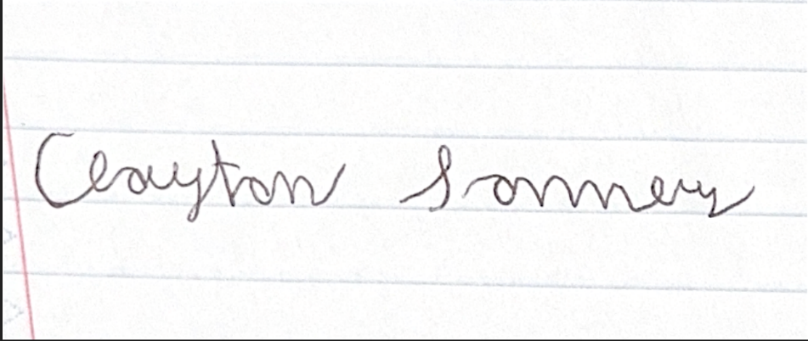
I, Brandon Smith; Agree with the details defined in this document that as well as future work involving this project was done as stated per the description of this document
Signature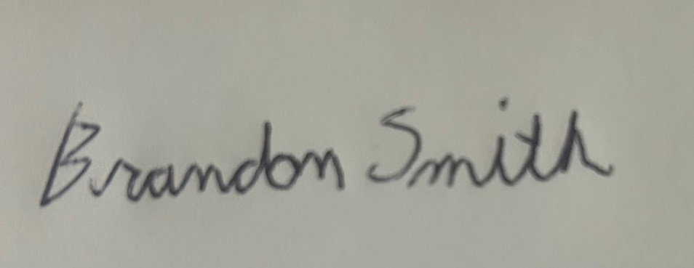
I, Alice Bruce; Agree with the details defined in this document that as well as future work involving this project was done as stated per the description of this document
Signature